Want to make a difference with your skills?
We are looking for mentors for high school students!

Our students really struggle in multiple classes and subjects, but especially in math and reading. If you have strong teaching and communication skills, as well as a passion for helping teenagers succeed, please apply!

This is a great opportunity to serve our community while developing your teaching and leadership experience.

Compensation: $9.25 per hour

School | Provo High School | Independence High School
Student Success Class | 12:55-2:15 PM Every other day (some weeks are MWF, some weeks are T and Th) | 1:21-2:06 PM* M-Th, 12:43-1:15 PM* F (7th period)  *subject to change
Afterschool | 2:15-4:15 PM Monday-Thursday | 2:55-4:30 PM Monday-Thursday
Work period | Wednesday August 13, 2014-Thursday May 28, 2015
 | Mentors are assigned a high school (according to availability) and must be able to work during the Student Success Class time at that school.
 | Mentors who are also able to attend after school tutoring 1-2 days a week are preferred.

Responsibilities
- Provide homework guidance (especially in math), feedback, and resources to students in a one-on-one correspondence
- Assist the teacher by motivating students to have high expectations and reach goals, including maintaining grades, attendance, and achieving the milestones of the class
- Keep track of students’ performance and report to a Teens Act teacher and Teens Act supervisors
- Attend weekly team meetings with your assigned school (PHS or IHS)

Qualifications
- Be able to mentor students during the College Preparation Class daily or every other day (depending on which school you work in)
- Strong math skills in order to help students with math homework
- Education major students (especially Secondary Education), strongly preferred
- Previous experience in teaching, mentoring, or working with at-risk youth is a plus
- Eager to work hard, maintain a positive and proactive attitude, team player
- Be able to speak Spanish, preferred
- Be able to work 8-10 hours a week (meetings + class + after school tutoring if available)
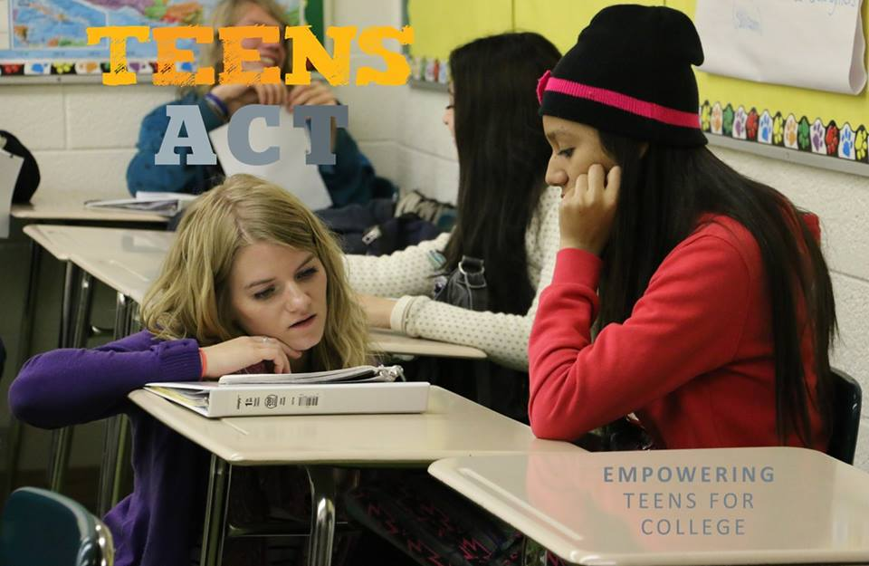
How to Apply
Submit a cover letter and a one-page resume to
contact@teens-act.org

Deadline
Open till filled & priority will be given to early applicants
(The final deadline is June 30th, 2015)

Any Questions?
Use the same email address or phone # (801-669-4462).
“I had two students come up to me after class and tell me how happy they are that they’ve been in this class and how proud they are of themselves because of their improvements. They’re grateful to set goals and see themselves meet those goals. Them saying that to me meant more than seeing their grades improve.”

-Melvin R (Provo High Teens Act Teacher 2014-2015)

