Summer Job Opportunity
UVU PREP
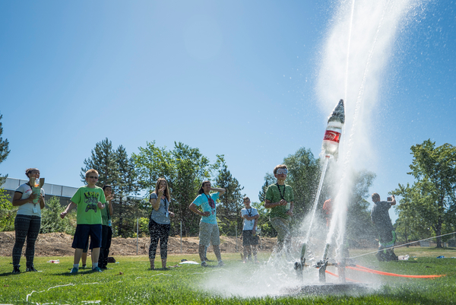
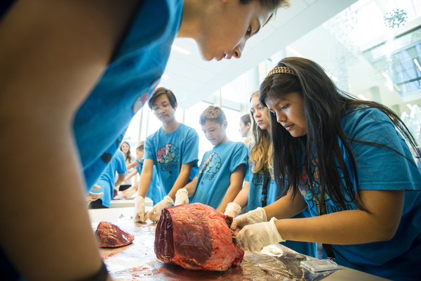

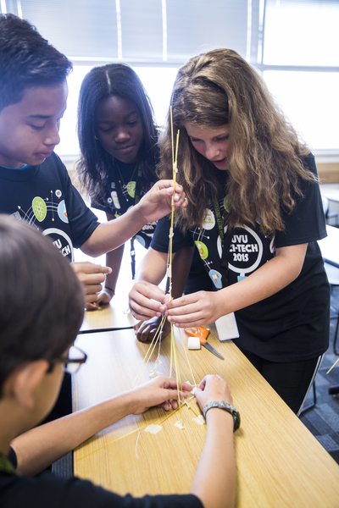
Teaching Assistants (TA) - (12 positions available) Seeking college students in the following majors: Secondary Education Math, Engineering, Math, Physics, and Science for TA positions to assist faculty with middle school students in a 7-week summer STEM program at UVU.

Program Assistant Mentors (PA) - (12 positions available)
Supervising and assisting middle school students in a 7-week summer STEM program at UVU. Secondary Education Math, Engineering, Math, Physics, and Science majors preferred, but not required.

- Must be available to work from May 23 to July 22 (except July 4th), 2016.
- 10:00 a.m. to 3:00 p.m., M-Th, and 8:00 a.m. to 3:00 p.m. on Friday.
- 28 hrs. /week at $10.00 per hour.

Apply now at: uvu.edu/jobs

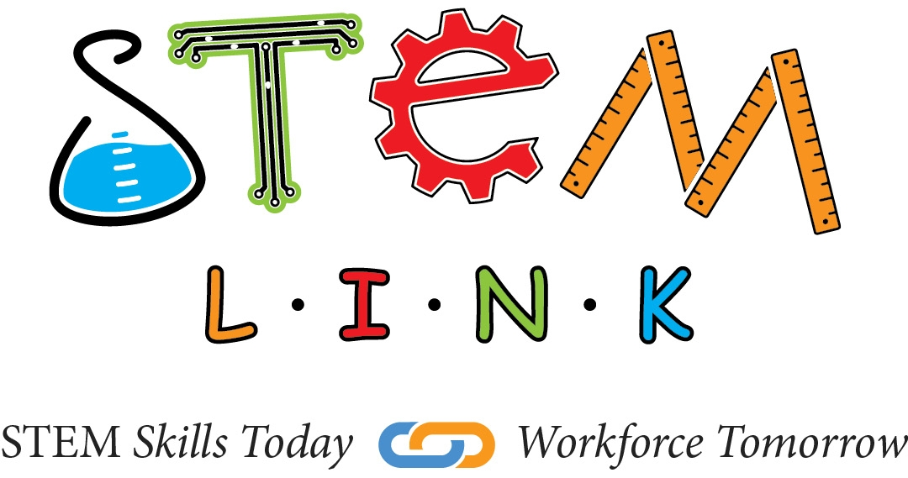
Any questions please contact us at:
partnership@uvu.edu or (801)863-6800
Summer Job Opportunity
UVU PREP

Teaching Assistants (TA) - (12 positions available) Seeking college students in the following majors: Secondary Education Math, Engineering, Math, Physics, and Science for TA positions to assist faculty with middle school students in a 7-week summer STEM program at UVU.

Program Assistant Mentors (PA) - (12 positions available)
Supervising and assisting middle school students in a 7-week summer STEM program at UVU. Secondary Education Math, Engineering, Math, Physics, and Science majors preferred, but not required.

- Must be available to work from May 23 to July 22 (except July 4th), 2016.
- 10:00 a.m. to 3:00 p.m., M-Th, and 8:00 a.m. to 3:00 p.m. on Friday.
- 28 hrs. /week at $10.00 per hour.

Apply now at: uvu.edu/jobs

Any questions please contact us at:
partnership@uvu.edu or (801)863-6800

